# Final RSI Backtest Strategy (Corrected)

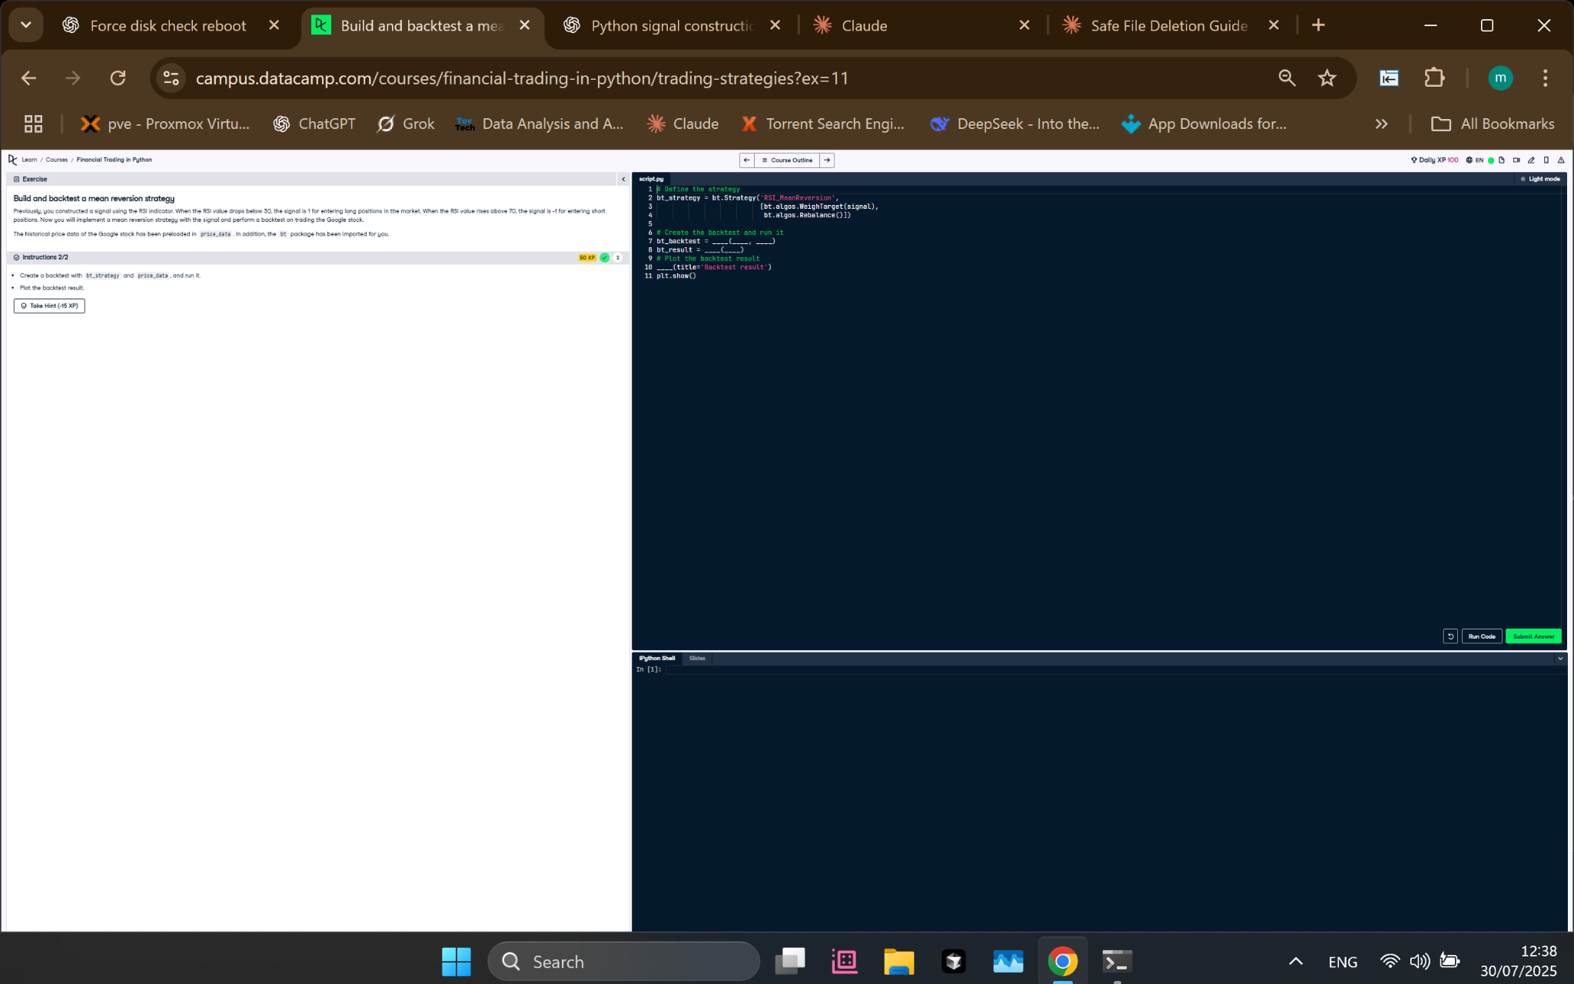

Figure: Corrected backtest setup applying only target weights and rebalancing.

## Python Code

# Define the strategy  
bt_strategy = bt.Strategy('RSI_MeanReversion',   
 [bt.algos.WeighTarget(signal),  
 bt.algos.Rebalance()])  
  
# Create the backtest and run it  
bt_backtest = bt.Backtest(bt_strategy, price_data)  
bt_result = bt.run(bt_backtest)  
  
# Plot the backtest result  
bt_result.plot(title='Backtest result')  
plt.show()

## Explanation

This final version defines a strategy using only `WeighTarget(signal)` and `Rebalance()`. It assumes the signal has already been filtered (non-tradable assets are set to 0), so there's no need for a separate selection step. The strategy is executed on historical price data, and the performance is visualized using `bt_result.plot()`.